**Linux Check Memory Usage**

**Posted on**[**April 6, 2006**](https://www.cyberciti.biz/faq/linux-check-memory-usage/)**in Categories**[**Linux**](https://www.cyberciti.biz/faq/category/linux/) last updated January 7, 2013

[](https://www.cyberciti.biz/faq/category/linux/)

How do I check used and free RAM memory usage under Linux operating systems using command line and GUI tools?  
  
Linux comes with different set of commands to check memory usage. The free command displays the total amount of free and used physical and swap memory in the system, as well as the buffers used by the kernel. The vmstat command reports information about processes, memory, paging, block IO, traps, and cpu activity. Finally, you can use the top, and/or atop/htop commands which provides a dynamic real-time view of a running system. top and friends can display system summary information as well as a list of tasks currently being managed by the Linux kernel.

**/proc/meminfo**

The /proc/meminfo file stores statistics about memory usage on the Linux based system. The same file is used by free and other utilities to report the amount of free and used memory (both physical and swap) on the system as well as the shared memory and buffers used by the kernel.

**Example**

Use the [cat command](https://www.cyberciti.biz/faq/howto-use-cat-command-in-unix-linux-shell-script/) or [grep command](https://www.cyberciti.biz/faq/howto-use-grep-command-in-linux-unix/) to see /proc/meminfo file:  
$ cat /proc/meminfo  
$ less /proc/meminfo  
$ more /proc/meminfo  
$ egrep --color 'Mem|Cache|Swap' /proc/meminfo  
Sample outputs:

MemTotal: 8120568 kB

MemFree: 2298932 kB

Cached: 1907240 kB

SwapCached: 0 kB

SwapTotal: 15859708 kB

SwapFree: 15859708 kB

**free command**

To display free memory size in MB (megabytes):  
$ free -m  
Sample outputs:

total used free shared buffers cached

Mem: 750 625 125 0 35 335

-/+ buffers/cache: 254 496

Swap: 956 0 956

Displays a line containing the totals memory in MB:  
$ free -t -m  
Output:

total used free shared buffers cached

Mem: 750 625 125 0 35 335

-/+ buffers/cache: 253 496

Swap: 956 0 956

Total: 1707 625 1082

**So how much free ram I have?**

Type the following command:  
$ free -m  
Sample outputs:

[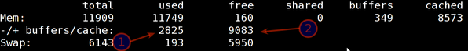](https://www.cyberciti.biz/faq/linux-check-memory-usage/understanding-free-command/)Understanding Free Command Output  
In this above output, my server has used 2825 MB ram, and 9083 MB is available for other users and programs.

**A list of free command options**

-b,-k,-m,-g show output in bytes, KB, MB, or GB

-l show detailed low and high memory statistics

-o use old format (no -/+buffers/cache line)

-t display total for RAM + swap

-s update every [delay] seconds

-c update [count] times

**vmstat command**

Type the vmstat command at shell prompt:  
$ vmstat  
Sample outputs:

procs -----------memory---------- ---swap-- -----io---- --system-- ----cpu----

r b swpd free buff cache si so bi bo in cs us sy id wa

1 0 0 131620 35432 341496 0 0 42 82 737 1364 15 3 81 1

**top command**

Type top command at the shell prompt:  
$ top  
Sample outputs:

[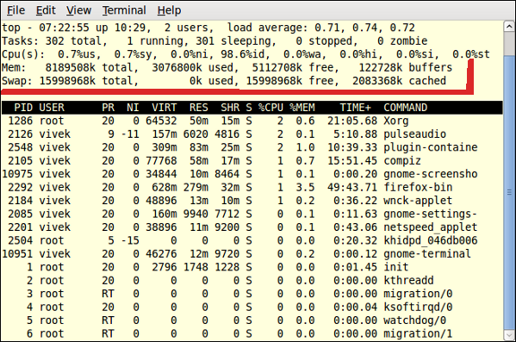](https://www.cyberciti.biz/faq/linux-check-memory-usage/linux-memory-usage-monitor-top-command/)Fig.01: top command displaying used memory  
To exit from top command type q key.

**atop command**

The program atop is an interactive monitor to view the load on a Linux system. This program can display the amount of used and free memory. It is similar to top command but comes with additional advanced options. By default, the atop command is not installed on most Linux distributions.  
$ atop  
Sample outputs:

[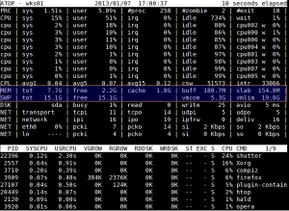](https://www.cyberciti.biz/faq/linux-check-memory-usage/atop-command-output/)Fig.02: Linux Check Amount Of Memory With atop Command

**htop command**

The program htop is an interactive process viewer. It is similar to top, but allows to scroll the list vertically and horizontally to see all processes and their full command lines.  
By default, the htop command is not installed on most Linux distributions.  
$ htop  
Sample outputs:

[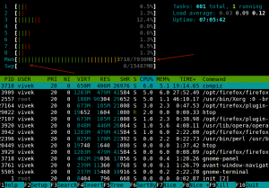](https://www.cyberciti.biz/faq/linux-check-memory-usage/htop-command-output/)Fig.03: Linux Check Amount Of Physical Memory With htop Command

**GNOME Desktop: GUI tool to see memory usage**

The “Gnome System Monitor” application enables you to display basic system information and monitor system processes, usage of system resources, and file systems. You can also use System Monitor to modify the behavior of your system. You can start System Monitor by visiting System menu > Choose Administration > System Monitor option. Or type the following command at the shell prompt:

|  |
| --- |
| gnome-system-monitor |

Sample outputs:

[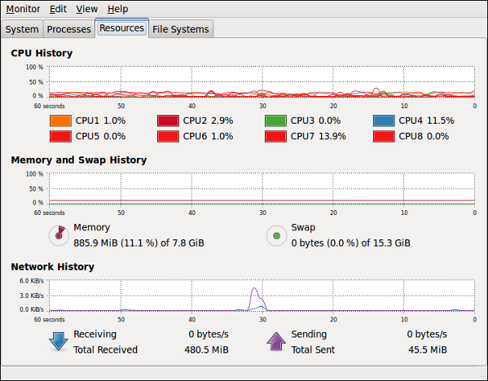](https://www.cyberciti.biz/faq/linux-check-memory-usage/screenshot-system-monitor/)Fig.04: Linux See Memory Usage With GUI System Monitor Tool

**Check out related media**

(Video 01: [Top five commands to see used and free memory under Linux](https://youtu.be/5lMfXXCzNAE))

**A note about the performance**

1. RAM – An occupation percentage of 90% is considered as critical.
2. SWAP – An occupation percentage of 80% is considered as critical.
3. To solve performance related problems, add more RAM and increase the swap space (or move swap space to another disk controller).

Read man pages of free, vmstat, top, atop, and htop commands for more information